**RESOURCES TO HELP CHILDREN EMOTIONALLY COPE IN THE AFTERMATH OF THE 2021 WINTER STORM DISASTER IN TEXAS**

[NORMAL CHILD REACTIONS AFTER A DISASTER](https://www.instagram.com/p/CLh3ZK0FTM4/) (For ages 0-10 of age))

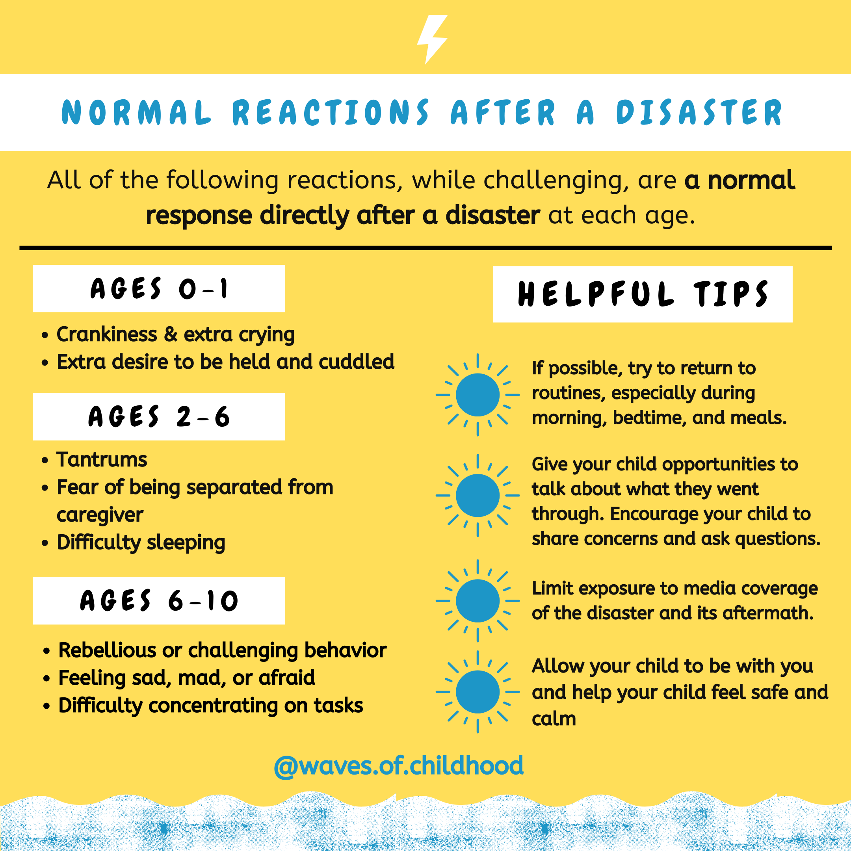

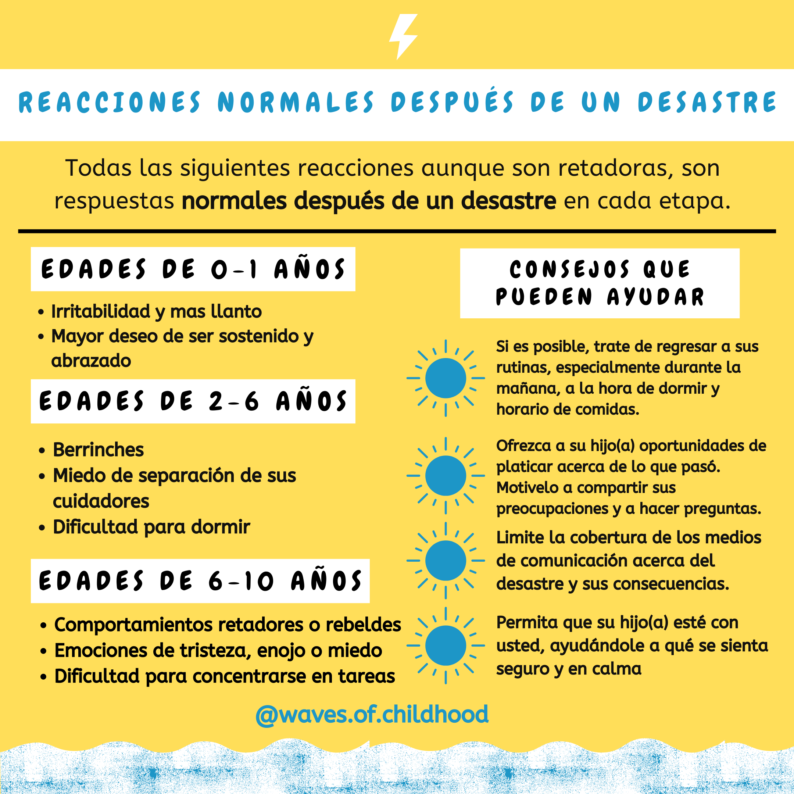

The winter storm has caused substantial harm to communities and families. After a disaster, children may have symptoms related to anxiety, depression, and PTSD. Many of these behaviors, though they are usually temporary, can be challenging for caregivers. First, normalize that your child may be acting out because of deeper reasons - even if they cannot express this to you. Then, take a breath, and try the tips listed here. See my other posts for more resources on how to talk about what happened.

Every child is different. If your child experiences any of the following, consider talking to your pediatrician or a children’s therapist:

⚡️Your child continues to be very upset (anxious, fearful, sad, angry) for more than 2 to 4 weeks after the disaster

⚡️Your child’s problems worsen instead of improve over time

⚡️Your child’s reactions affect their schoolwork or relationships with friends or family for a prolonged period

Adapted from the CDC’s “Helping Your Child Cope with a Disaster”:

<https://www.cdc.gov/childrenindisasters/children-disaster-help.html#:~:text=Immediately%20after%20a%20disaster%2C%20children,and%20difficulty%20concentrating%20on%20tasks>.

Spanish translation by Johanna Hosking-Pulido, Dusana Schnell & Ivan Quintero

Created by: Erin Givarz (MSW) and Vanessa R. (LPC) of Austin, TX

IG: @waves.of.childhood (Erin) @humandivergence (Vanessa)

FB: [www.facebook.com/humandivergence/](http://www.facebook.com/humandivergence/) (Vanessa)

⚠️ [AFTER THE STORM: TALKING TO KIDS WHEN DISASTER STRIKES](https://www.instagram.com/p/CLh02O6F_dv/) ⚠️ Ages 2.5-10

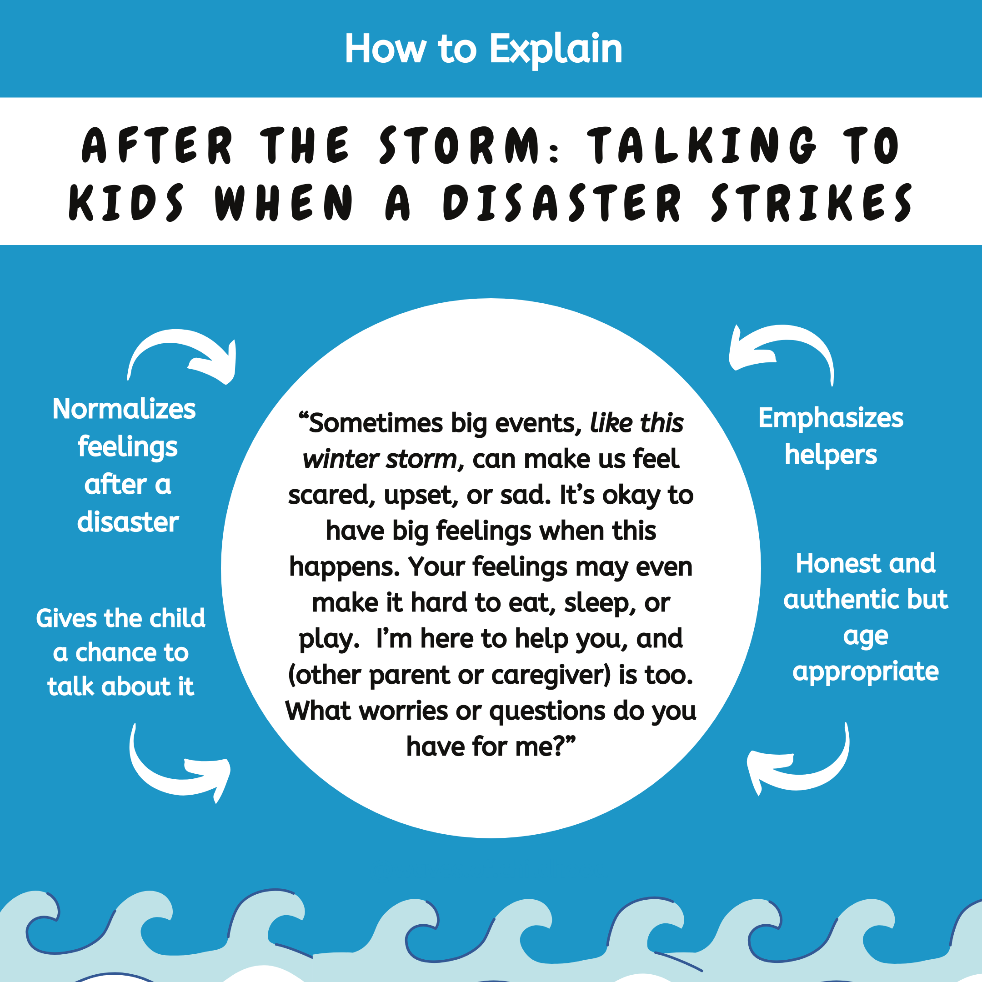

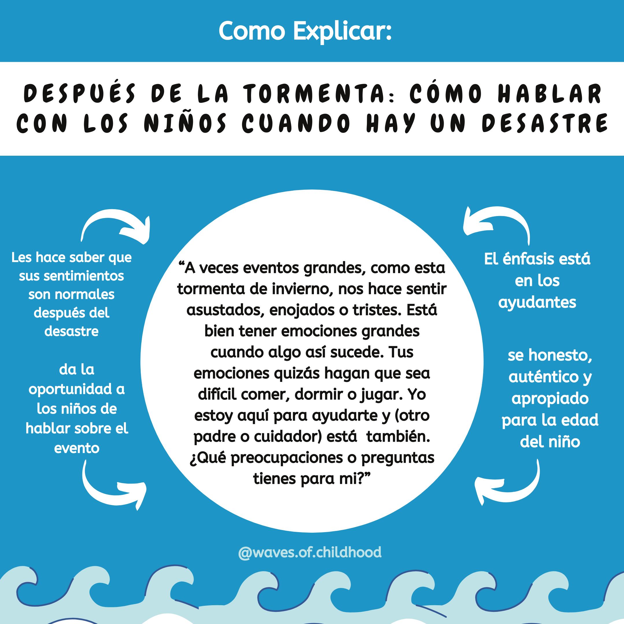

🌨Disaster can cause more severe emotional distress for children, even babies, because they:

⚡️May not understand fully what is going on

⚡️May feel more out of control

⚡️May have less experience with stressful events

⚡️May not have the capacity to communicate their feelings.

Parents can step in to help their child cope with big feelings related to the event.

🌨Use this script as a guide and take out/fill in what feels appropriate to your situation. Feel free to pause at any time and assess your child’s reaction. Encourage your child to ask questions or share concerns. It’s okay if your child does not want to share. Use gentle touch and a soft tone if they are overwhelmed with the feelings that come up for them.

Adapted from the CDC’s “Helping Your Child Cope with a Disaster”

<https://www.cdc.gov/childrenindisasters/children-disaster-help.html#:~:text=Immediately%20after%20a%20disaster%2C%20children,and%20difficulty%20concentrating%20on%20tasks>.

[🍃HELPING YOUR CHILD REWRITE A NARRATIVE ABOUT A DISASTER🍃](https://www.instagram.com/p/CLiVRR2F_RU/) for ages 2-18

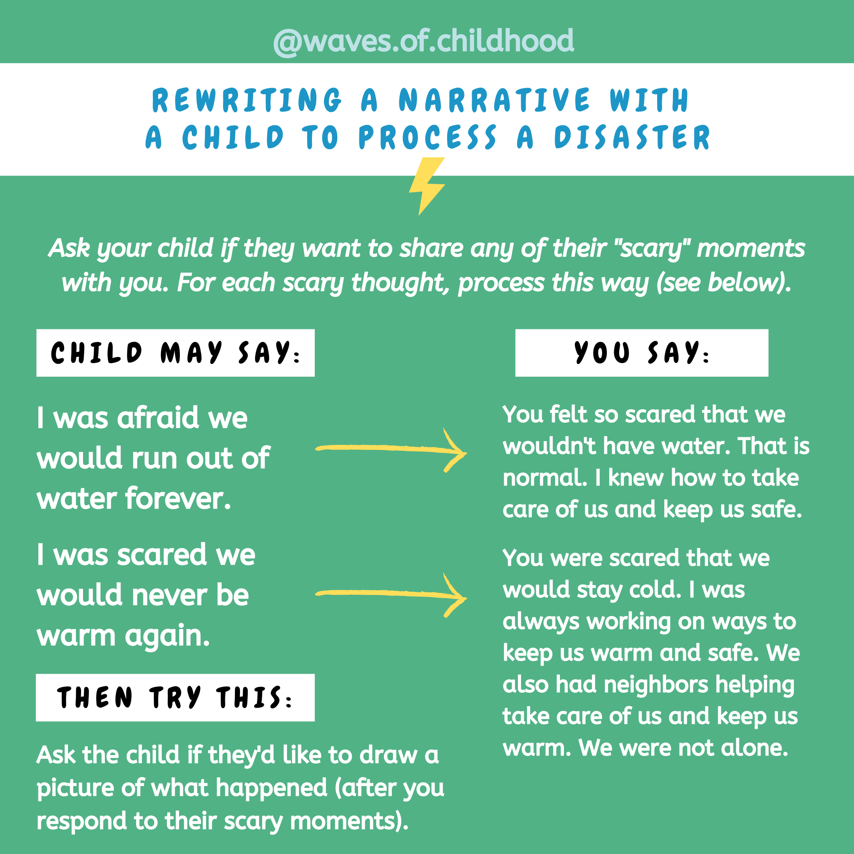

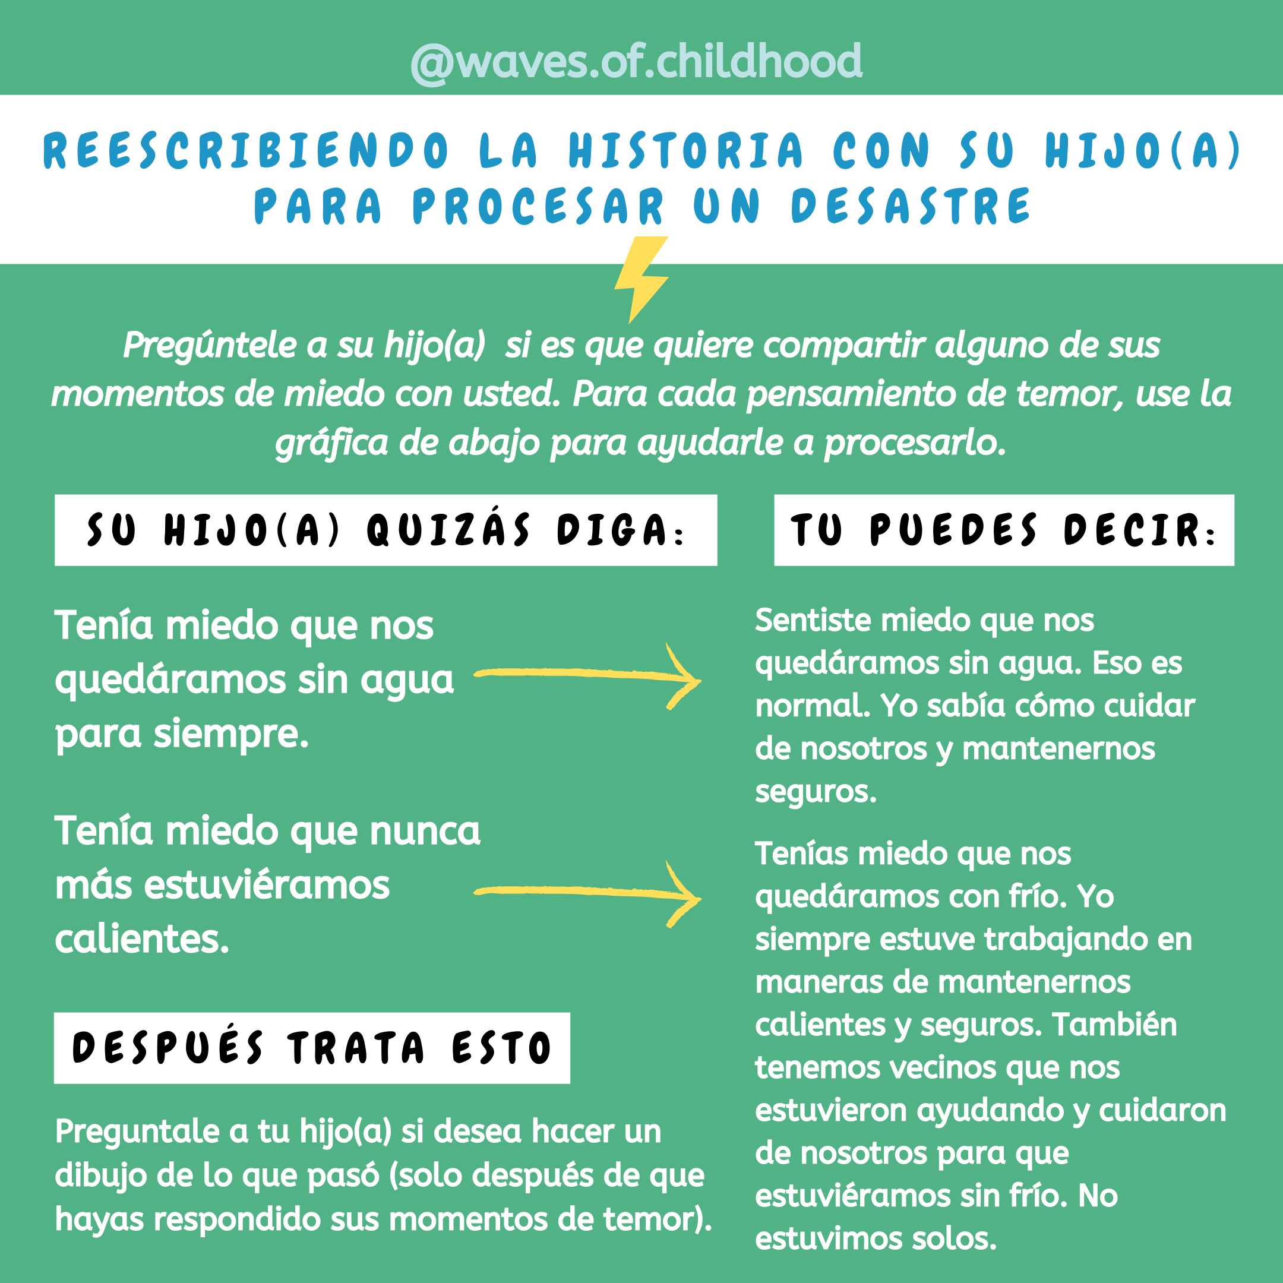

🌻When you and your child are safe and you feel like you are ready, here’s a great technique you can use to help your child cope emotionally.

🌻This technique is related to a therapeutic process called a “trauma narrative”. Though not every disaster is experienced as traumatic for every child, this strategy helps by allowing your child to share their fear based feelings and memories with you after the family is more regulated.

🌻If you can revisit that scary feeling for them later when you are regulated, then you help them regulate those scary feelings they kept stored because you were unavailable. This creates a coherent and resilient narrative. (⚠️ NOTE: For chronic or extreme trauma [such as abuse] this technique is ONLY to be done by a licensed professional.)

1️⃣ Choose a calm moment with your kid and say something like “Whoa. Those were some stressful days we had. How did you feel? Were there some things that were scary for you?”

2️⃣ Allow the child to share scary moments with you.

3️⃣ One by one remind them of ways they were safe even when they weren’t aware of that safety - because they were so scared (and so were you!).

4️⃣ Ask the child if they'd like to draw a picture of what happened (after you respond to their scary moments).

🌻If your child has no interest processing or has nothing they report they want to process then you just say “Okay. I am here if you ever need to explore this” or “I know that was scary for me and it’s okay it wasn’t scary for you. I know I wasn’t as available as I usually am and I feel so much better now and want to be there for you.”

For younger kids (under 3) a simple “I am here now. You are safe” is enough. For adolescents (14-18), there is less of a script - simply listening to their experience once you are regulated and resourced and offering any support or needed repair is appropriate.

Adapted from: https://www.ahaparenting.com/ask-the-doctor-1/helping-kids-heal-from-trauma-by-making-a-book

***Other resources*:**

If you have kiddos who watch Daniel Tiger’s Neighborhood and/or Arthur on PBS kids, they may benefit from the following episodes Free on PBS KIDS app or streaming on Amazon Prime Video (subscription only)

Daniel Tiger’s Neighborhood - Season 2 Episode 10 “A Storm in the Neighborhood/After the Neighborhood Storm”

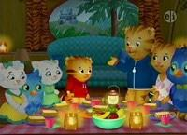

There's a big storm coming to the Neighborhood. Daniel and his friends are a little frightened at first, but the grown-ups have a plan to keep everyone safe. / The big storm that came through the Neighborhood has passed. But now everything looks different, with leaves all over, trees knocked down and window shutters fallen — it's a scary thing for Daniel and his friends to see. But they are comforted to know that everyone is safe and there are helpers everywhere, coming together to fix the Neighborhood. Strategy: Take a grown-up’s hand, follow the plan and you’ll be safe.

Arthur - Season 18 Episode 10 “Shelter From the Storm” (Parts 1 & 2)

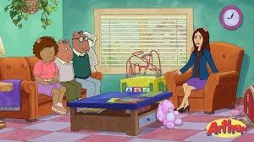

When a powerful hurricane hits Elwood City, everyone's affected. Ladonna’s dad is called up by the Army Corps of Engineers. Muffy relocates to a shelter, while Arthur struggles to reunite lost pets and owners. And Brain seeks the help of a therapist — voiced by special guest Idina Menzel — to help him manage his anxiety. Educational objective: Arthur and friends realize the importance of family, friendship, and the support and compassion of others in times of crisis.